

**Homework # 3**

**01286121 Computer Programming**

**Software Engineering Program,**

**Department of Computer Engineering,**

**School of Engineering, KMITL**

By

**66011533**  **Eaint Kay Khaing Kyaw**

1.Write a program that reads the following information and prints a payroll statement: Employee’s name (e.g., Smith) Number of hours worked in a week (e.g., 10) Hourly pay rate (e.g., 9.75) Federal tax withholding rate (e.g., 20%) State tax withholding rate (e.g., 9%).

**The Program Codes:**

## The program prints the payroll statement.

# user input

name = input("Enter Employee's name:")

hours = float(input("Enter Number of hours worked in a week:"))

Hpay_rate = float(input("Enter Hourly pay rate($):"))

Ftax_rate = float(input("Enter Federal tax withholding rate(eg.0.2 for 20%):"))

Stax_rate = float(input(("Enter State tax withholding rate(eg.0.09 for 9%):")))

Gross_pay = hours * Hpay_rate

# Deductions

F_withhold = Ftax_rate * Gross_pay

S_withhold = Stax_rate * Gross_pay

T_deductions = F_withhold + S_withhold

Net_pay = Gross_pay-T_deductions

# Payroll Statement

print("\nEmployee name:", name)

print("Hours worked:", hours)

print("Pay rate: ${:.2f}".format(Hpay_rate))

print("Gross Pay: ${:.2f}".format(Gross_pay))

print("Deductions:")

print("\t", "Federal withholding({:.2%}) : ${:.2f}".format(Ftax_rate,F_withhold))

print("\t", "State withholding({:.2%}) : ${:.2f}".format(Stax_rate,S_withhold))

print("\t", "Total Deductions: ${:.2f}".format(T_deductions))

print("Net pay: ${:.2f}.".format(Net_pay))

**Results of Code**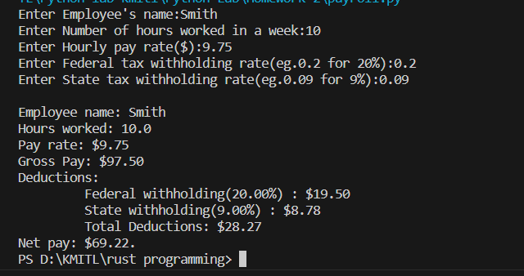

2. Write a program that prompts the user to enter a four-digit integer and displays the number in reverse order.

**The Program Codes:**

## The program displays the user input number in reverse order.

# user input

F_integer = input("Enter a four-digit integer:")

# integer to string

S_integer = str(F_integer)

# Input to reverse order

reverse_num = S_integer[::-1]

print("The input number in reverse order is:", reverse_num)

**Result of Codes:**

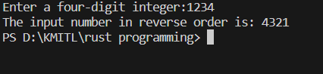

3. Write a program that prompts the user to enter the length of the star and draw a star. (Hint: The inner angle of each point in the star is 36 degrees.)

**The Program Codes:**

## This Program will display a star that has 36 degrees angles.

import turtle

# user input

l_star = float(input("Enter desired length of a star:"))

# Draw the star

turtle.forward(l_star)

turtle.right(144)

turtle.forward(l_star)

turtle.right(144)

turtle.forward(l_star)

turtle.right(144)

turtle.forward(l_star)

turtle.right(144)

turtle.forward(l_star)

turtle.hideturtle()

turtle.done()

**Results of Codes:**

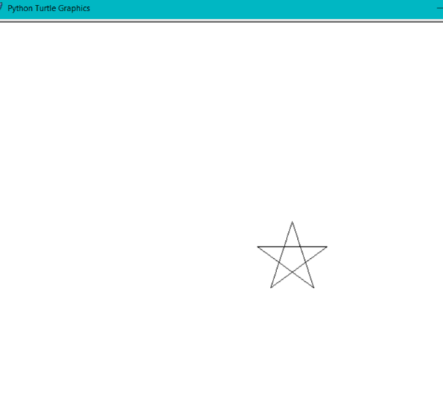

4. Write a program that prompts the user to enter the radius of the ring and draws an Olympic symbol of five rings of the same size with the colors blue, black, red, yellow and green.

**The Program Codes:**

# This program displays n Olympic symbol of five rings of the same size.

import turtle

gap = 20                               #constant gap between circles

turtle.hideturtle()

# user input

radius = float(input("Enter the radius of the ring:"))

# Draw Blue Circle

turtle.color("blue")

turtle.circle(radius)

# Change the position of turtle

turtle.penup()

turtle.forward((2*radius) + gap)

turtle.pendown()

#Draw Black Circle

turtle.color("black")

turtle.circle(radius)

# Change the position of turtle

turtle.penup()

turtle.forward((2*radius) + gap)

turtle.pendown()

#Draw Red Circle

turtle.color("red")

turtle.circle(radius)

# Change the position of turtle

turtle.penup()

turtle.backward(radius + (gap/2))

turtle.right(90)

turtle.forward(radius)

turtle.left(90)

turtle.pendown()

# Draw yellow Circle

turtle.color("yellow")

turtle.circle(radius)

# Change the position of turtle

turtle.penup()

turtle.backward((2*radius) + gap)

turtle.pendown()

#Draw green Circle

turtle.color("green")

turtle.circle(radius)

turtle.done()

**Results of Codes**

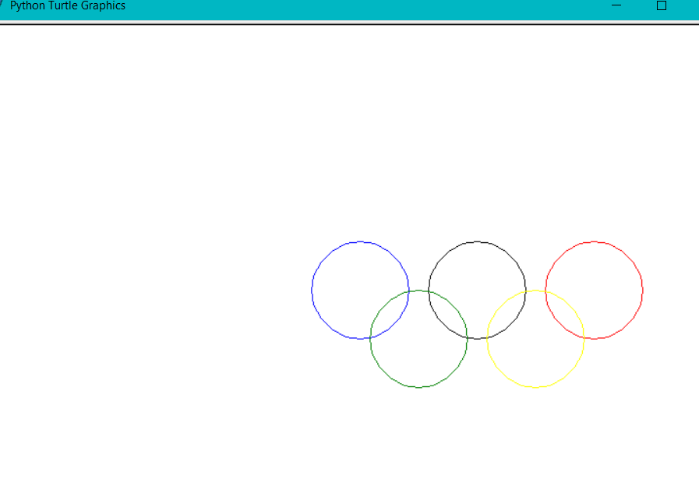

5. Write a program that prompts the user to enter the three point p1, p2 and p3 for a triangle and display its area below the triangle.

**The Program Codes:**

## This Program displays a triangle and its area.

import turtle

import math

turtle.hideturtle()

# Prompt the user for inputting three points of a triangle

x1, y1 = eval(input("Enter x1 and y1 for p1 (eg. x1,y1): "))

x2, y2 = eval(input("Enter x2 and y2 for p2 (eg. x2,y2): "))

x3, y3 = eval(input("Enter x3 and y3 for p3 (eg. x3,y3): "))

# Compute the sides of a triangle

s1 = math.sqrt((x2-x1)**2 +(y2-y1)**2)

s2 = math.sqrt((x3-x2)**2 +(y3-y2)**2)

s3 = math.sqrt((x3-x1)**2 +(y3-y1)**2)

# side 1

turtle.penup()

turtle.goto(x1,y1)            # Move to p1

turtle.pendown()

turtle.write("p1")

turtle.goto(x2,y2)

turtle.write("p2")            # Move to p2 and form side 1

#side 2

turtle.goto(x3,y3)             #Move to P3 and form side 2

turtle.write("p3")

#side 3

turtle.goto(x1,y1)           #Move to p1 and form side 3

# Compute the area

s = (s1 + s2 + s3)/2

area = math.sqrt(s*(s-s1)*(s-s2)*(s-s3))

tri_area = "Area of a triangle: {:.2f} ".format(area)

# write the area below triangle

turtle.penup()

turtle.sety(-100)

turtle.pendown()

turtle.write(tri_area)

turtle.done()

**Results of Codes**

